**Mahatma Students Club celebrated birth day of P. Bhavani II B. Com student on 13.07.2022**

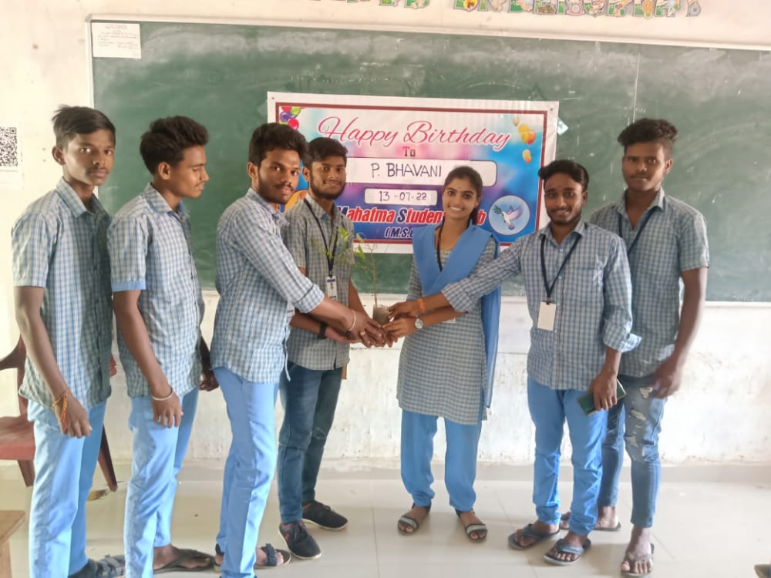 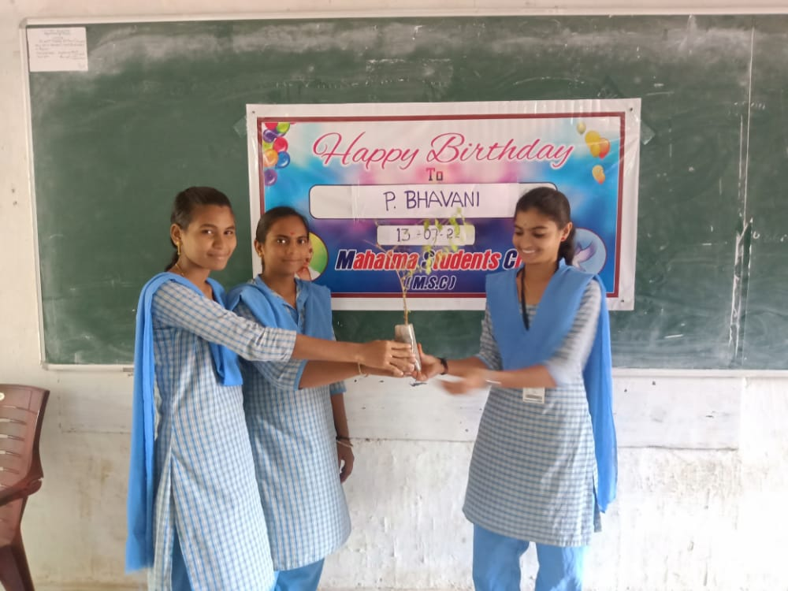

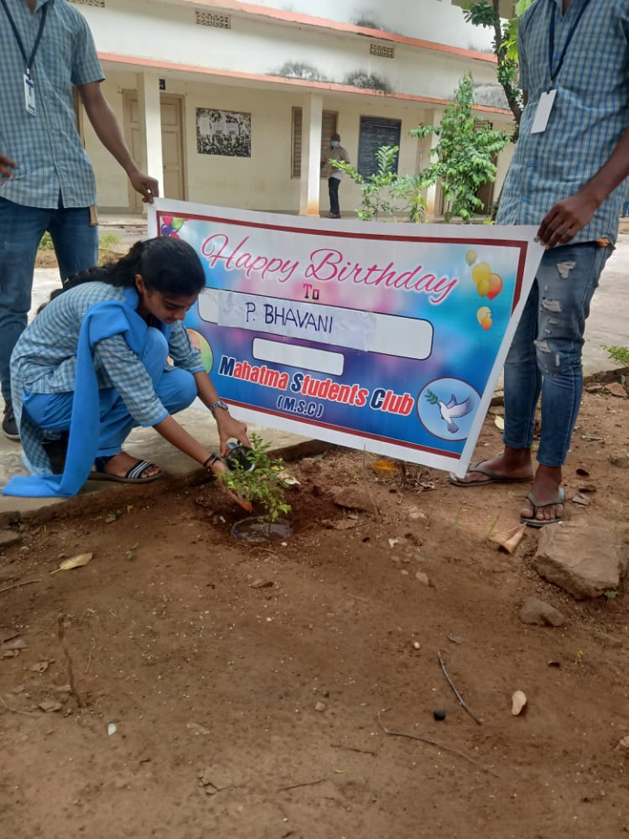

**CH.KANAKA MAHALAKSHMI’S (STUDENT OF II B.COM) BIRTHDAY WAS CELEBRATED ON 01.8.2022 BY HER CLASS MATES BY DONATING PLANT. SHE PLANTED THE SAPLING IN THE COLLEGE CAMPUS AND**

**TOOK RESPONSIBILITY TO ITS GROWTH**

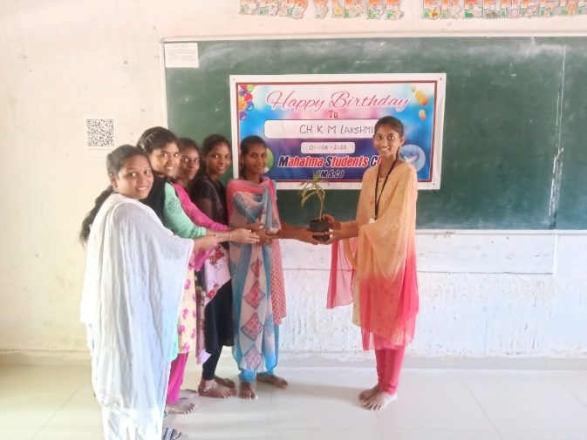 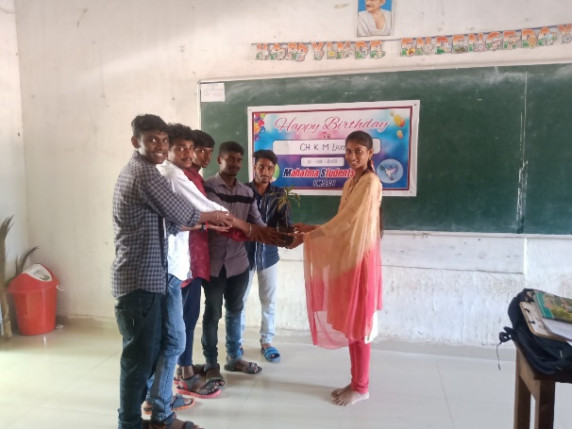

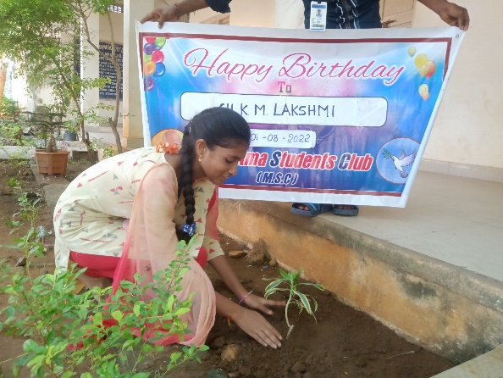 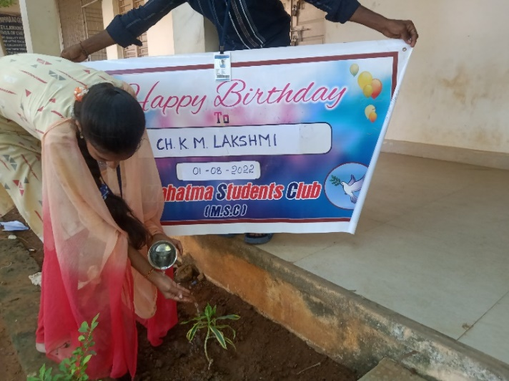

**G.SURYA LAKSHMI’S (2ND B.COM) BIRTHDAY WAS CELEBRATED ON 03.8.2022 BY HER CLASS MATES BY DONATING PLANT. SHE PLANTED THE SAPLING IN THE COLLEGE CAMPUS AND**

**HAS TAKEN RESPONSIBILITY TO ITS GROWTH**

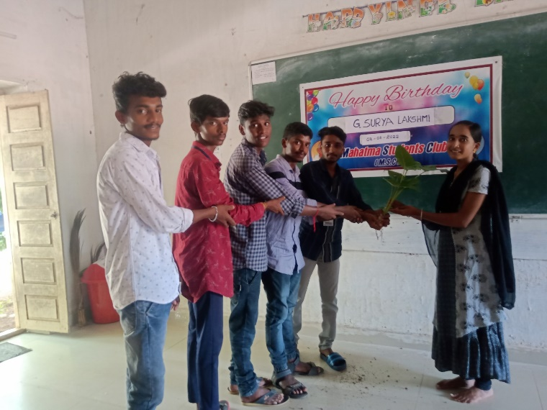 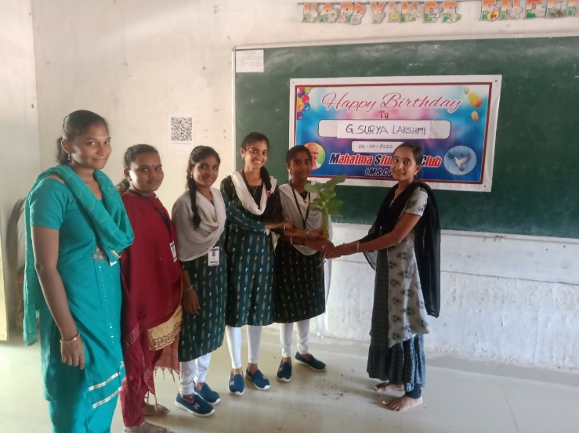

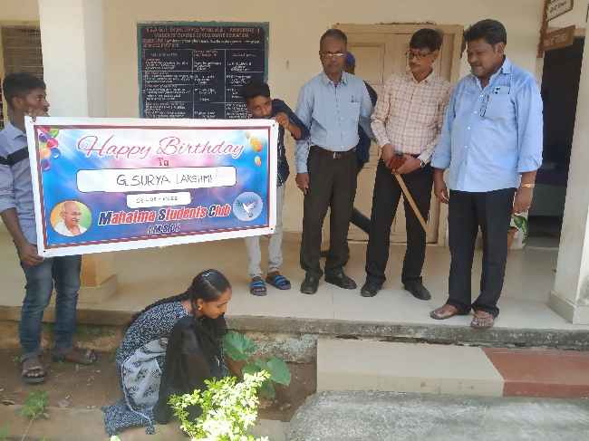 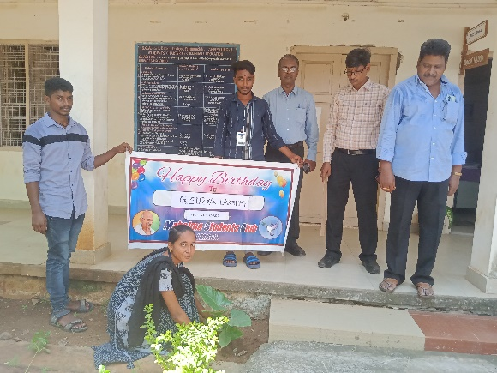

**G.NAGA LAKSHMI’S ( II B.COM) BIRTHDAY WAS CELEBRATED ON 15.8.2022 BY HER CLASS MATES BY DONATING PLANT. SHE PLANTED THE SAPLING IN THE COLLEGE CAMPUS AND**

**HAS TAKEN RESPONSIBILITY TO ITS GROWTH**

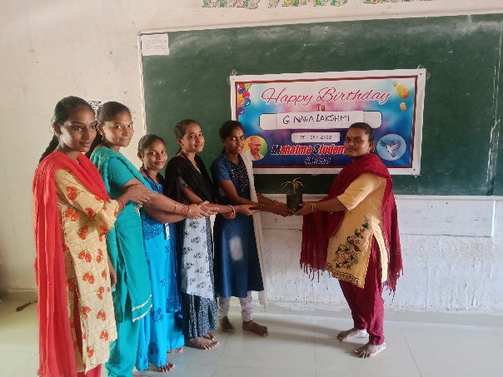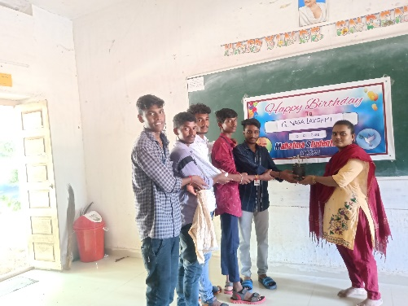

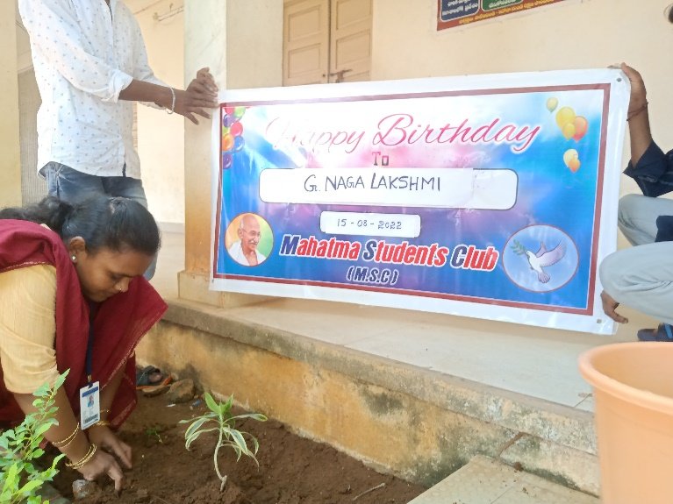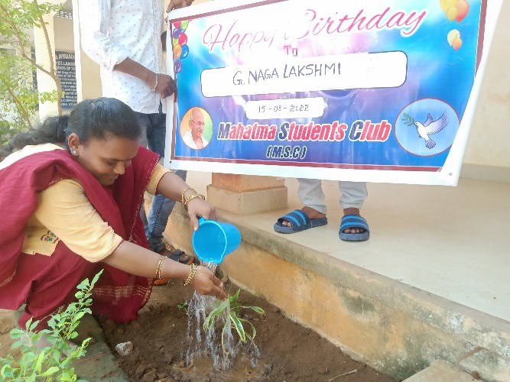

**K. PRAVALLIKA DEVI’S (2NS B.COM) BIRTHDAY WAS CELEBRATED ON 16.8.2022 BY HER CLASS MATES BY DONATING PLANT. SHE PLANTED THE SAPLING IN THE COLLEGE CAMPUS AND**

**HAS TAKEN RESPONSIBILITY TO ITS GROWTH**

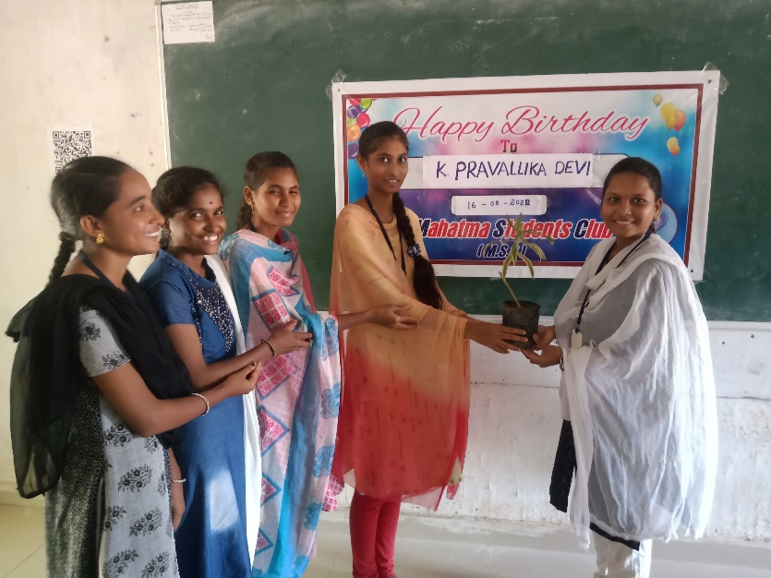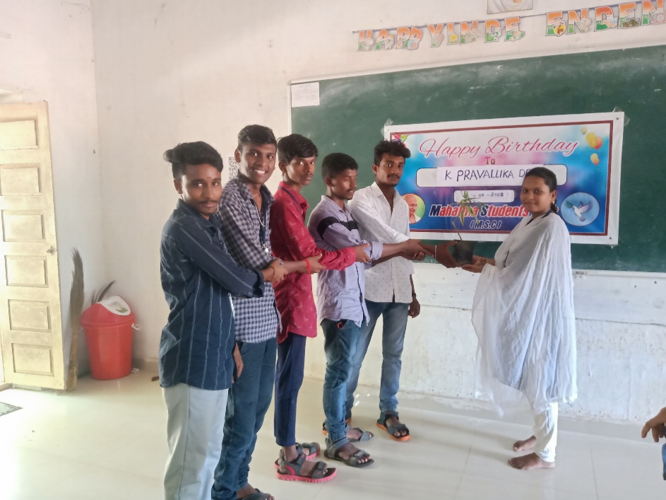

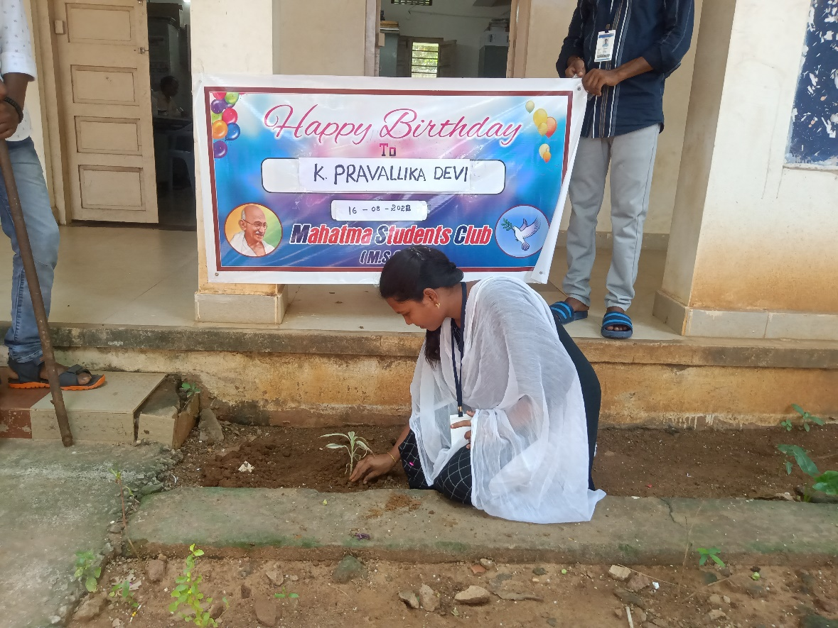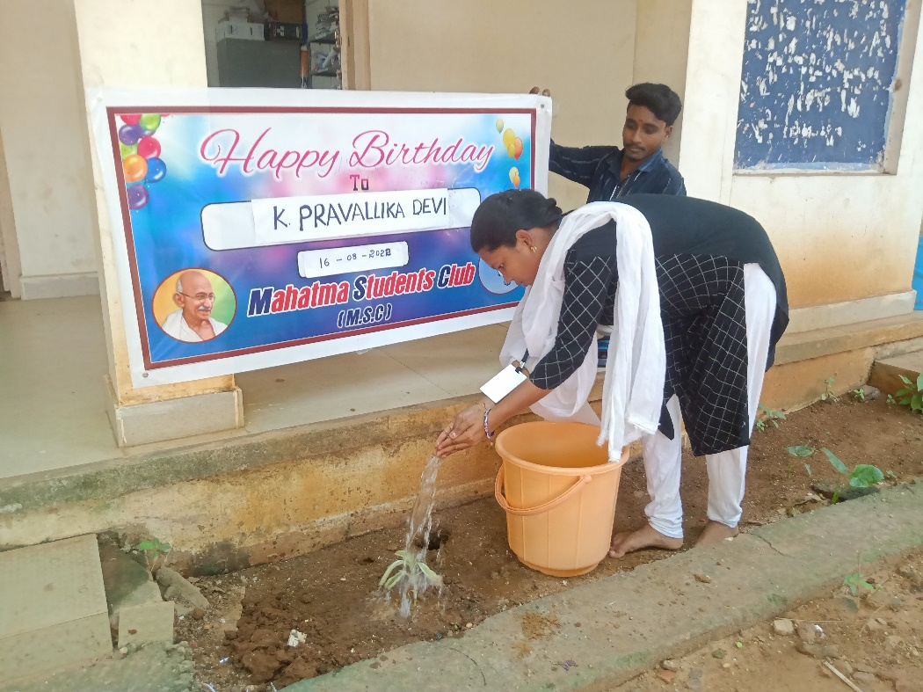

**U.NAVEEN (2ND B.COM) BIRTHDAY WAS CELEBRATED ON 15.9.2022 BY HER CLASS MATES BY DONATING PLANT. HE PLANTED THE SAPLING IN THE COLLEGE CAMPUS AND**

**HAS TAKEN RESPONSIBILITY TO ITS GROWTH**

